

Dr. Melissa, Sellers inc.
2022-06-15
Dr. Sellers
2606 Adam Courts, Port Jessicaborough, MD 61462
Phone: 3833538232
Fax: 135259262

Re: Mary, Tran
PHN: 3676450498
Birthdate: 18-Oct-1953
Address: 578 Castillo Estates Apt. 376, Danielville, NH 71240
Patient number: 8364382829

To Whom It May Concern:

This is a medical letter to state the above patient is pregnant with expected delivery date of 19-Aug-2025. Hoping this information is satisfactory for your requirements.

Thank you.

Sincerely,
Dr. Melissa, Sellers
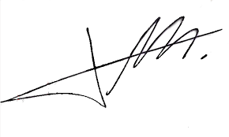
FRCS© NCMP
Clinical Assistant Professor, UBC
Department of Obstetrics and Gynecology SMH

